Charge Flow : An IOT Enabled Smart Solar EV Charging Station

A Project Report Submitted by:

- Syed Farhan Hashmi (RVCE25BCS008)- Computer Science & Engineering
- Rithvik Chennupati (RVCE25BCS306)- Computer Science & Engineering
- Alvin K Boby (RVCE25BEC197) - Electronics & Communication Engineering
- Abhinand N Shamin (RVCE25BEC203)- Electronics & Communication Engineering

Mentor - Dr. Madhu B.R

- Introduction
The transportation sector is currently undergoing a drastic shift toward Electric Vehicles (EVs). However, this shift faces significant hurdles, primarily the lack of charging infrastructure and the environmental impact of sourcing electricity from non-renewable sources like coal. This project introduces ChargeFlow, a smart solar EV charging station that integrates renewable energy with a user-friendly website. By providing a decentralized, off-grid charging solution and a centralized platform for locating stations, ChargeFlow aims to reduce "range anxiety" and promote sustainable mobility.

- Problem Definition
  - Problem Statement:
EV users currently face "range anxiety" and "charger anxiety" due to the difficulty in locating functional and available charging stations. Additionally, the rapid rise in EV adoption poses a risk of overloading power grids if charging demand is not managed efficiently. Consequently, charging EVs via the normal power grid often merely shifts pollution sources rather than eliminating them. There is a critical need for a smart, IoTbased system that offers real-time station tracking, availability monitoring, and utilizes renewable energy.
  - Background Information: (literature review)
      - State of Charge (SOC) and State of Health (SOH) Estimation: Accurate estimation of battery parameters is essential for the reliable performance of electric vehicles. As detailed by Murnane and Ghazel, techniques such as Coulomb counting are vital for determining the State of Charge (SOC) and State of Health (SOH) of a battery. These metrics allow the system to monitor battery health effectively, ensuring that users have precise information regarding their vehicle's charging status.
      - Global Standardization Challenges: The electric vehicle landscape is fragmented by varying charging standards across different regions. Research by Rachidi et al. highlights that North America typically uses SAE J1772 or CCS
Type 1, while Europe adopts Type 2 or CCS Type 2, and Japan uses CHAdeMO. This lack of standardization complicates cross-border compatibility and necessitates infrastructure that can support multiple inlet types and communication protocols.
      - IoT and Smart Charging Infrastructure: Previous studies, such as those by Sanadi et al., have explored IoT-enabled solar charging stations that utilize web servers for authentication and real-time monitoring. However, viability gaps remain; while these systems can track specific stations, many existing location tracking databases are confined to specific modules and lack effective volume routing, which limits their effectiveness in addressing range anxiety for a broader user base.
      - Renewable Energy Integration: To mitigate the environmental impact of charging, integrating renewable energy is crucial. Shaikh et al. emphasize that solar energy offers a renewable, eco-friendly power source that significantly lowers dependence on the main power grid. Implementing photovoltaic systems with energy storage ensures cost-efficient charging and promotes a sustainable transportation ecosystem by reducing carbon emissions.

- Objectives
Primary Objectives:
    - To design a solar-powered, IoT-integrated EV charging system to enhance reliability and accessibility.
    - To develop a real-time web platform that allows users to locate and monitor charging stations easily.
    - To implement smart IoT features for load balancing to optimize performance.
Secondary Objectives:
    - To identify the key causes of charging anxiety among EV users through data analysis.
    - To evaluate the system's efficiency and impact on reducing grid strain.

3. Methodology
4.1 Approach:
The project adopts a mixed-methods approach, combining qualitative user-centric design with quantitative IoT data analysis. The system architecture integrates a physical charging station (hardware) with a cloud-based software ecosystem.
  - Hardware Logic: A controller switches between solar and grid power based on availability. An ultrasonic sensor detects vehicle presence to determine vacancy.
  - Software Logic: Data is transmitted via ESP32 to a Firebase Realtime Database. The user website interacts with APIs (OpenChargeMap, GraphHopper) to provide routing and status updates.
4.2 Procedures:
    - Data Collection: IoT sensors collect telemetry data (vacancy status), while user interaction data is gathered via the web app.
    - Data Transmission: The ESP32 microcontroller processes station status and transmits it via Wi-Fi to the Firebase Realtime Database.
    - Data Analysis: The system performs descriptive analytics on usage trends and compatibility mapping to match EVs with available chargers.
    - System Integration: The hardware and software are linked via the cloud, enabling the web app to display real-time availability.

- Project Execution
  - Planning and Design:
The project began with an Initiation Phase (Weeks 1-2) to identify resources and define goals. This was followed by a Planning Phase (Weeks 3-4), which involved creating a detailed project plan, conducting feasibility studies, and reviewing research papers to determine the appropriate methodology.
  - Implementation:
During the Execution Phase (Weeks 5-10), the team integrated the Solar-Powered Charging Hardware with the IoT and User-Centric Access Platform.
    - Hardware Assembly: Solar panels, battery banks, and the ESP32 microcontroller were assembled with a relay system to manage power switching.
    - Software Development: The website was built using HTML, CSS, and JavaScript, integrated with Firebase for real-time data handling.

- Tools and Techniques Used
  - Tools:
    - ESP32 Microcontroller: Acts as the IoT core for communication between hardware and software.
    - Ultrasonic Sensor (HC-SR04): Detects vehicle distance to check for vacancy.
    - Firebase Realtime Database: Stores and processes data with low latency.
APIs:
    - OpenChargeMap: For station data.
    - GraphHopper: For route optimization.
    - OpenStreetMap: For rendering map layers.
    - Solar Components: Solar panels, TP4056 (protection), and Relay modules
  - Techniques:
    - IoT Sensing and Telemetry: Utilizing ultrasonic sensors to set a specific distance threshold (50cm) for determining "Occupied" vs. "Vacant" status automatically.
    - Hybrid Power Switching: Implementing a relay-based logic to switch power sources. When solar capacity drops below 40%, the system automatically switches to the DC grid, ensuring uninterrupted power

- Partial Results
  - Initial Findings:
Early testing focused on the accuracy of the vacancy detection. It was determined that a threshold limit was necessary for the ultrasonic sensor to accurately log the station status. Additionally, the need for a seamless switch between renewable and non-renewable energy sources was identified to prevent power interruptions.

  - Iterative Improvements:
    - Threshold Calibration: The ultrasonic sensor threshold was set to 50cm. If an object is detected within this range, the ESP32 logs the station as occupied; otherwise, it is available.
    - Power Management Logic: The relay logic was refined so that when battery capacity drops below 40%, it triggers a switch to grid power. Conversely, when the station is idle, it reverts to solar to conserve energy.
- Results and Discussion
  - Final Results:
The deployed ChargeFlow system was successfully tested for three critical parameters:
    - Location Depiction: The station is accurately represented as a dynamic pointer on the map based on ESP32 geolocation data.
    - Availability Updates: The system continuously interacts with the Realtime Database to update the station's color on the map (indicating vacancy) based on sensor data.
    - Power Switching: The hybrid power switching efficiently managed the transition between solar and DC grid inputs.
  - Discussion:
The project successfully met its primary objectives. It demonstrated that a solar-powered EV charging infrastructure with IoT integration is feasible and can be optimized for user convenience. The integration of multiple APIs (OpenStreetMap, GraphHopper) proved effective in creating a seamless user interface that addresses range anxiety
- Prototype (Hardware/Software)
  - Prototype Description:
    - Hardware: The physical unit consists of a 3W solar panel charging a buffer battery, an ESP32 microcontroller, a double channel relay, a buck converter, and an HC-SR04 ultrasonic sensor.
    - Software: A web-based application featuring a map interface that displays station location, real-time vacancy (via color coding), and routing options. It includes an AI chatbot for user assistance.
  - Development Process:
The development bridged the gap between physical components and the digital interface using a cloud-based methodology. A key challenge was ensuring data flows securely and quickly from the hardware to the Firebase database, which was solved by utilizing the ESP32's built-in Wi-Fi capabilities.
  - Testing and Validation:
The prototype underwent testing for slot vacancy detection and power management efficiency. The system was validated by verifying that the web interface correctly updated the "Live" status and color indicators immediately after the ultrasonic sensor detected a vehicle. 10. Conclusion
  - Summary:
ChargeFlow delivers a complete ecosystem that is user-friendly, intelligent, and sustainable. By integrating solar energy with IoT monitoring, the project addresses the critical issues of range anxiety and grid strain. The successful deployment of the prototype proves that renewable energy can be effectively managed and monitored to provide a reliable charging experience.
  - Personal Reflection:
    - Student 1 (Syed Farhan Hashmi): Working on the software integration for ChargeFlow deepened my understanding of how full-stack web development interacts with IoT hardware. Integrating Firebase with OpenChargeMap and GraphHopper APIs was a significant learning curve that improved my problem-solving skills regarding real-time data visualization.
    - Student 2 (Rithvik Chennupati): This project provided hands-on experience with hardware logic and power management. Designing the relay switching system for hybrid energy sources highlighted the practical challenges of sustainable engineering. I learned the importance of precise sensor calibration (ultrasonic threshold) in creating reliable automated systems.
    - Student 3 (Alvin K Boby): The collaborative nature of this project helped me understand the complete lifecycle of a product, from literature review to prototype execution. I gained valuable insights into how distinct technologies—solar panels, microcontrollers, and web apps—must be synchronized to create a cohesive smart city solution.
    - Student 4 (Abhinand N Shamin): As an ECE student, this project bridged the gap between theoretical circuit analysis and practical application. Working on the hardware interface for the ultrasonic sensors and ensuring the stability of the solar panel connections helped me understand the complexities of powering IoT devices in off-grid scenarios.

- Visuals:
  - "System Architecture of ChargeFlow" diagram
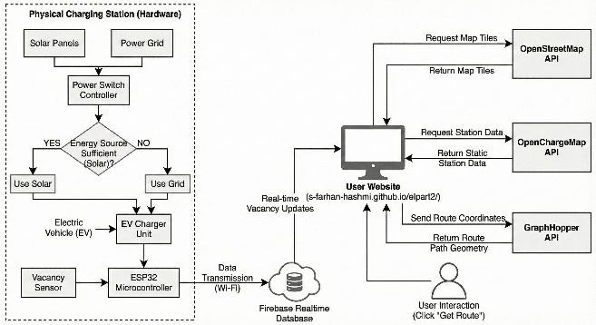
  - "Integrated Methodology" chart
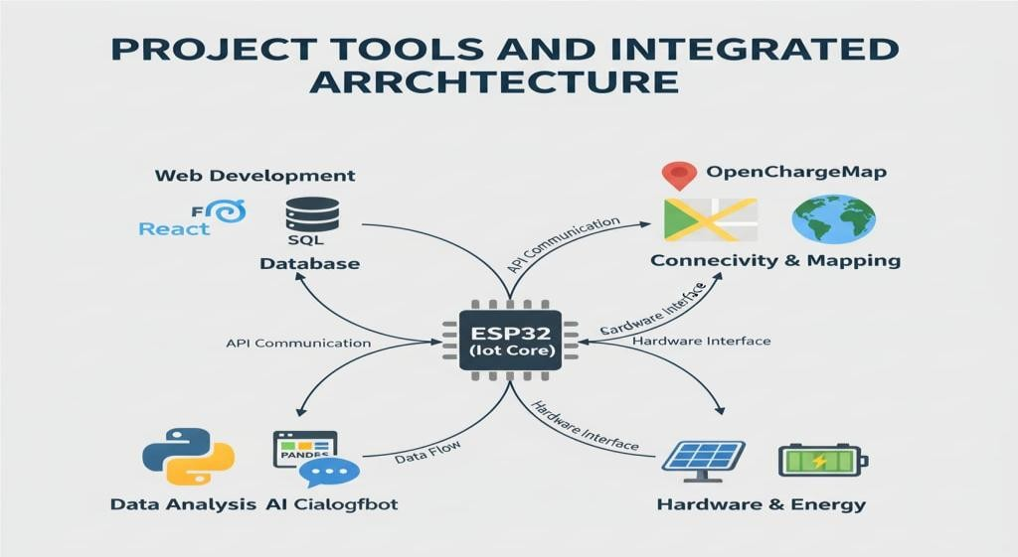
  - "User Website" interface

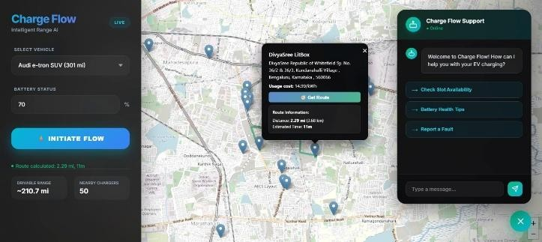

- Outcome of the work:
The outcome of this work has been documented in a technical paper titled "Charge Flow: An IOT Enabled Smart Solar EV Charging Station." The paper details the system architecture, hardware components, and software integration, contributing to the field of sustainable urban mobility and smart city infrastructure. The project serves as a blueprint for future green transportation solutions.

References
- REFERENCE-1: Murnane, M., & Ghazel, A. (2017). A closer look at state of charge (SOC) and state of health (SOH) estimation techniques for batteries (Technical Article). Analog Devices, Inc. https://www.analog.com/en/resources/technical-articles/a-closer-look-atstate-of-charge-and-state-health-estimation-tech.html
- REFERENCE-2: Rachid, A., El Fadil, H., Gaouzi, K., Rachid, K., Lassioui, A., El Idrissi, Z., & Koundi, M. (2023). Electric Vehicle Charging Systems: Comprehensive Review. Energies, 16(1), 255. https://doi.org/10.3390/en16010255
- REFERENCE-3: Sanadi, R. A., Patil, G. M., Patil, R. M., Sankpal, A. P., & Shete, S. S. (2022).
IoT Enabled Smart Charging Station For Electric Vehicles. IJSART-International Journal of
Scientific and Advanced Research in Technology, 8(7), 40–42. https://ijsart.com/public/storage/paper/pdf/IJSARTV8I755519.pdf
- REFERENCE-4: Shaikh, M. R. S., Waghmare, S. B., Labade, S. S., Fuke, P. V., & Tekale, A. (2017). A Review Paper on Electricity Generation from Solar Energy. International Journal for Research in Applied Science & Engineering Technology (IJRASET), 5(9), 1884– 1889. https://www.researchgate.net/publication/320226399_A_Review_Paper_on_Electricity_G eneration_from_Solar_Energy
- REFERENCE-5:NITI Aayog, e-Amrit. (2022, January 14). Standards and specifications.
https://e-amrit.niti.gov.in/standards-and-specifications

